Name _________________ Per. ________ Date ______________________
Ch.6 – Section 2 – Key Concepts Check-up

1. Identify this person from Section 2. What important pamphlet did he write? How did he change the colonists’ attitudes toward King George and Britain? What were some arguments that he used in his writing to persuade the colonists to declare independence?
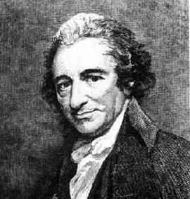
________________________________________________________________________________________________________________________________________________________________________________________________________________________________________________________________________________________________________________________________________________________________________________________________________________________________________________________________________________________________________________

2. Name three people who were on the committee to write the Declaration of Independence. Who was the main author?
_____________________________________________________________________________________________________________________________________________________________________________________________________________________
3. According to the Declaration of Independence, why do people form governments? Explain what the Declaration says citizens have the right to do if a government fails to protect their rights?
___________________________________________________________________________________________________________________________________________________________________________________________________________________________________________________________________________________________________________________________________________________________________

