Name _____________________________ Per. ________ Date ________________

Independence Hall - Philadelphia, PA - Travel Through History

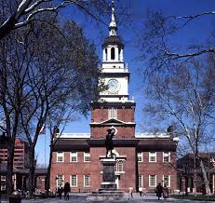
https://www.youtube.com/watch?v=M8egp_3ewfs

1. William Watson, Park Guide at Independence National Park, states at the beginning of this video that when you come to Independence Hall “you are going to see, most importantly, the birthplace of the United States.”
Cite three pieces of evidence from the video clip to support Ranger Watson’s statement.
- ____________________________________________________________________________________________________________________________________
- ____________________________________________________________________________________________________________________________________
- ____________________________________________________________________________________________________________________________________
2. Formerly known as the State House of Pennsylvania, Independence Hall most likely got its current name from the French General Lafayette. Cite evidence from the video to support this claim.
______________________________________________________________________________________________________________________________________________

3. It has been said that Philadelphia was THE place to be between the writing of the Declaration of Independence and the Constitution. Cite three pieces of evidence from the video to support this claim.
- ____________________________________________________________________________________________________________________________________
- ____________________________________________________________________________________________________________________________________
- ____________________________________________________________________________________________________________________________________

